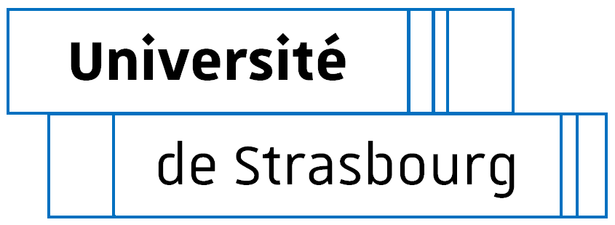

DOCTORAL COLLEGE - UNIVERSITY OF STRASBOURG
Individual training convention

Between :
- The doctoral student
- Title, first name, name: [title, family name, first name] if applicable, usual name: [usual name]
- Date, place and country of birth: on [date], at [place + country]
- Nationality: [nationality]
- INE No.: [INE]
- Address: [home address]
- Mobile phone number: (Mob. No.)
Hereinafter referred to as "the doctoral student" on the one hand.
And
- The thesis supervisor
- Title, first name, family name: Title, family name, first name]
- Grade: GRADE
- Research Unit : RU
- Number of supervisors:
Hereinafter referred to as "the thesis supervisor" on the other hand.
- Co-supervisor, if applicable:
- Title, first name, family name: Title, family name, first name]
- Grade: GRADE
- Research Unit : RU
- Number of supervisors:
Hereinafter referred to as "the co-thesis supervisor" on the other hand.
- The thesis supervisor in a company or private organization, if applicable:
- Civility, first name, last name:
- Rank:
- Company/organization:
- Quota of supervision :
Hereinafter referred to as “company supervisor” on the other hand.
Under the aegis of:
- The Research Unit:
- Label - Name of the research unit
- Director [Family name + first name of the director]
Hereinafter referred to as the "research unit" on the other hand.

- The doctoral college:
- National number - heading
- Director / Co-Director: [Title - First name - family name]
Hereinafter referred to as "the ED" on the other hand.

Being hereinafter jointly referred to as the PARTIES.

- Given Article L612-7 of the Education Code, Given Articles L412-1 and L412-2 of the Research Code,
- Given the Decree of 25 May 2016 laying down the national training framework and the procedures leading to the award of the national doctoral diploma,
- Given the doctoral charter of the University ....
- Given the rules of procedure of the Doctoral College...,
- Given the international co-supervision of theses between the University ... .. and [denomination of partner institution, city, country]

The PARTIES have agreed upon the following:
Article 1: The administrative framework
The doctoral project is prepared, in line with all the general conditions in force at the University (Strasbourg or UHA) and specific conditions at the doctoral college (DC Name) as part of a University doctoral degree registration in (Strasbourg or UHA) as of the academic year [Date 1st Adm Registration]. Where applicable: The doctoral project is conducted within the framework of an international co-supervision of theses, with [denomination of partner institution, city, country].
The research project has the following characteristics:

- Title of the thesis: [title of thesis]

- Doctoral field: [field]

Hours of work and remuneration dedicated to doctoral studies
☐ full time and remuneration dedicated to the preparation of the doctorate (e.g.: doctoral contract)
☐ part time and remuneration not dedicated to the preparation of the doctorate (e.g.: secondary school teacher)
☐ other case : specify

Remuneration from [start date] to [end date] included.
- Position: [type of contract]
- Employer: [employer]
- Source of the funding dedicated to the preparation of the doctorate: [source of funds]

If remuneration is less than 36 months, it is imperative to indicate the projected financing plan (source and duration of funding):

Article 2: Research project sequence and accompanying arrangements
The methods of integration into the unit or the research team are in accordance with the rules of procedure of the research unit and the doctoral charter.
Summary of the research project (10 lines maximum) :

Projected schedule of the research project: (indicate the main scientific milestones and possible travelling projects)

[Projected schedule]

Methods of supervision, follow-up of training and progress of doctoral research (methods and means) - reference may be made to the doctoral school's regulations:
- Organisation of doctoral student follow-up (identify all the advisors, frequency of interviews with supervisors, delivery of progress reports by doctoral student)

- Inception of the monitoring committee

- Prerequisites for thesis defence

Material scientific (working environment, specific safety conditions, access to equipment, etc.) and financial conditions (assumption of operating and mission expenses) of the research project:
Reference may be made to the internal rules of the unit, where applicable, for material conditions. Questions on the financing of missions, participation in seminars and symposia will be discussed.

Article 3: Appreciation of research work
Confidential work: ☐ yes ☐ no
In accordance with the institution's policy concerning doctoral training (charter), define the objectives of the doctoral student's research (dissemination, publication, authors and confidentiality). Evoke the principles of signing works, intellectual property, and other points related to the management of results and data.

Article 4: Choice of future profession:
Doctoral place in the profession, skills targeted during doctoral studies (maximum 15 lines)
This is a draft project that can be revised. The choice of profession must not be incompatible with the conditions for writing the thesis, in particular the clauses related to the appreciation of research.

Individual forecast training plan for the doctoral project and the professional project
The individual plan can be based on the training model of the DC but also on the transversal training provided by the doctoral college. It may also refer to personalised training provided outside the College and related to the professional skills to be acquired.

List of desired training courses (in accordance with the doctoral school regulations): non exhaustive list
Disciplinary courses:
Title of courses | Year

Transversal courses: proposed by the Doctoral College:
- Strasbourg: http://www.unistra.fr/index.php?id=17333
- Mulhouse: http://www.ecoledoctorale.uha.fr/?page_id=2761
(The information extracted from these conventions will enable the Doctoral College - University of Strasbourg to offer a catalogue of transversal training courses in line with the requirements of doctoral students at each of the Strasbourg and Mulhouse sites.

Category | Course title | Number of hours | Year

Other courses:
Title | Number of hours | Year

Each doctoral student must follow a training course dedicated to research ethics and another to research integrity. These two courses are offered annually by the doctoral college-University of Strasbourg.

As a signatory of this convention, I acknowledge that I have read and agree to abide by it.
The doctoral student:  Signed in [date]  [Title, First name, Family name] | Thesis supervisor:  Signed in [date]  [Title, First name, Family name]
If applicable, the co-supervisor:  Signed in [date]  [Title, First name, Family name] | If applicable, the company supervisor:  Signed in [date]  [Title, First name, Family name]
Head of the research unit:  Signed in [date]  [Title, First name, Family name] | The doctoral college:  Signed in [date]  [Title, First name, Family name]

